**Python Code TEST**

**PYTHON STW 121**

**Softwarica College of IT and E-Commerce**

1. Write a calculator code in Python.

Basics Concept:

1. Ask the user for input
2. Conditionally select an operation based on the operator chosen
3. Perform the calculation using the selected operator
4. Print the result

Output:

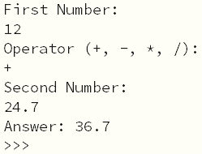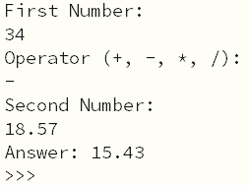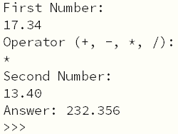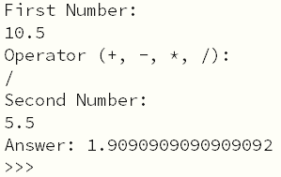

Ans:

num1 = float(input("Enter first number: "))

operator = input("Enter the operator(+,-,*,/) : ")

num2 = float(input("Enter the second number: "))

if operator == '+':

    print(num1 + num2)

elif operator == '-':

    print(num1 - num2)

elif operator == '*':

    print(num1 * num2)

elif operator =='/':

    print(num1 / num2)

1. Calculate discount based on sale amount.

Given discount rates:

|  |  |
| --- | --- |
| Amount | Discount |
| 0 - 5000 | 5 % |
| 5000 - 10000 | 10 % |
| 10000 - 15000 | 20 % |
| Above 15000 | 30 % |

Output:

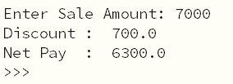

Ans:

a = int(input("Enter the amount: "))

if a <= 5000:

    d = a * 5/100

elif a <= 10000:

    d =a * 10/100

elif a <= 15000:

    d = a * 20/100

elif a > 15000:

    d = a * 30/100

print("Discount :",d)

n = a - d

print("Net pay :",n)

1. Write a password generator in Python. Be creative with how you generate passwords - strong passwords have a mix of lowercase letters, uppercase letters, numbers, and symbols. The passwords should be random, generating a new password every time the user asks for a new password. Include your code in a main method. [len==8]

Ans:

import string

import random

def password(userInput):

    specialCharacter = [random.choice(string.punctuation) for character in range(userInput)]

    wordLower = [random.choice(string.ascii_lowercase) for lower in range(userInput)]

    wordUpper = [random.choice(string.ascii_uppercase) for upper in range(userInput)]

    numbers = [random.choice(string.digits) for number in range(userInput)]

    generatedPassword = ''.join(specialCharacter + wordLower + wordUpper + numbers)

    generatedPassword = ''.join(random.choice(generatedPassword) for value in range(userInput))

    return generatedPassword

question = int(input('Please enter the password length: '))

answer = password(question)

print(answer)

1. Write the code of the ATM process.

**Hint: We can use the while True loop because it will loop forever**

Output:

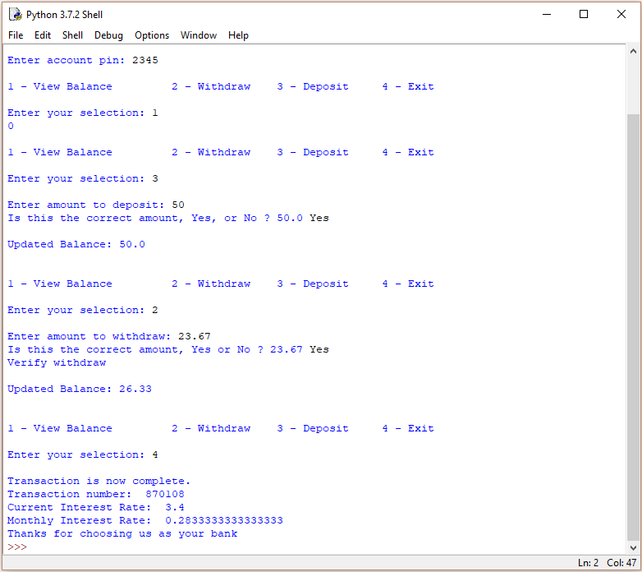

Ans:

while True:

    pin = int(input("Enter account pin : "))

    if pin == 2345:

        while True:

            print("1- View Balance   2- Withdraw   3- Deposite   4- Exit" )

            selection = int(input("Enter your selection : "))

            if selection == 1:

                print("0")

            elif selection == 2:

                amounttowithdraw = float(input("Enter amount to withdraw : "))

                print("Is this the correct amount, Yes or No ?",amounttowithdraw)

                if input() == 'Yes':

                    print("Verify withdraw")

            elif selection == 3:

                amounttodeposit = float(input("Enter amount to deposit : "))

                print("Is this the correct amount, Yes or No ?",amounttodeposit)

                if input() == 'Yes':

                    print("Update Balance : ",amounttodeposit)

            elif selection == 4:

                print("Transaction is now complete.")

                print("Transaction number: 870108")

                print("Current Interest rate: 3.4")

                print("Monthly Interest rate: 0.2833333333")

                print("Thanks for choosing us as your bank")

                break

1. Write the code to check the leap year.

**Hint: A year which is divisible by 400, or, a year divisible by 4 but not divisible 100, is a leap year.**

Output:

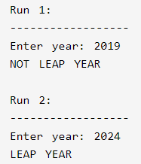

**Ans:**

year = int(input("Enter year: "))

if year%400 == 0 or year%4 == 0:

    print("LEAP YEAR")

elif year%100 == 0:

    print("NOT LEAP YEAR")

else:

    print("NOT LEAP YEAR")

1. Find the factorial of a given number:

**Hint:**7!=7*6*5*4*3*2*1=5040

Output:

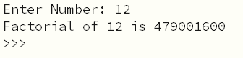

Ans:

def factorial(num):

    if num == 1:

        return num

    else:

        return num * factorial(num - 1)

num = int(input("Enter Number : "))

if num < 0:

    print("factorial cannot be found.")

else:

    print("Factorial of ",num," is ",factorial(num))